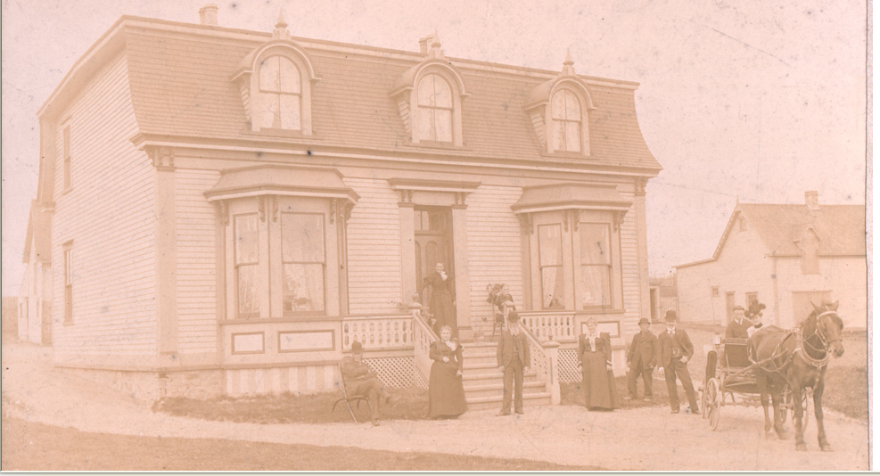

the house on Pennywell Road when it was Coadys’ Farm – date unknown
from the street looking north
a farm building covers the Thistle Yard

